SUMMER GUITAR SPECTACULAR
‘SIX HANDS’
Three of the world’s finest guitarists on one glorious night
JOHN WILLIAMS
JOHN ETHERIDGE
GARY RYAN
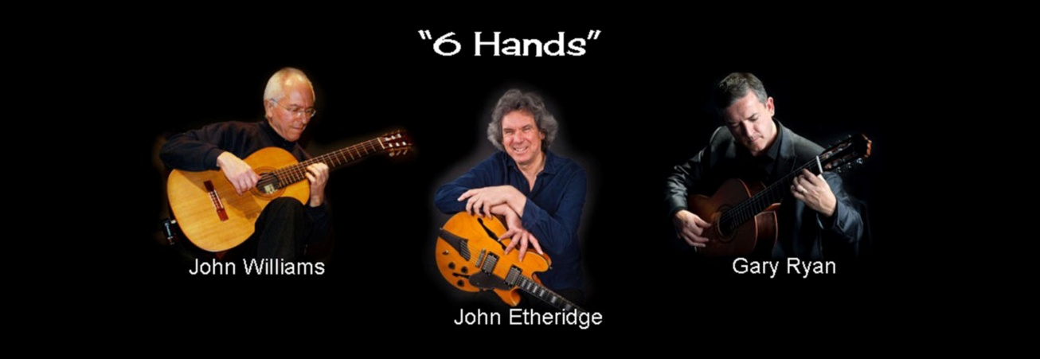

Frant Church
High Street, Frant
(Nr. Tunbridge Wells) TN3 9DX
Tickets £20 from
Frant Stores
Britten’s Music Shop Tunbridge Wells or
www.wegottickets.com or
01892 750665
Friday 22 June 2018
8 pm (doors open @ 7.30 pm)
Licensed bar area
A fund-raising concert for the conservation of Frant Church Reg. Charity 1162531

