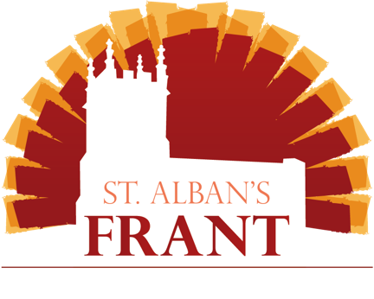
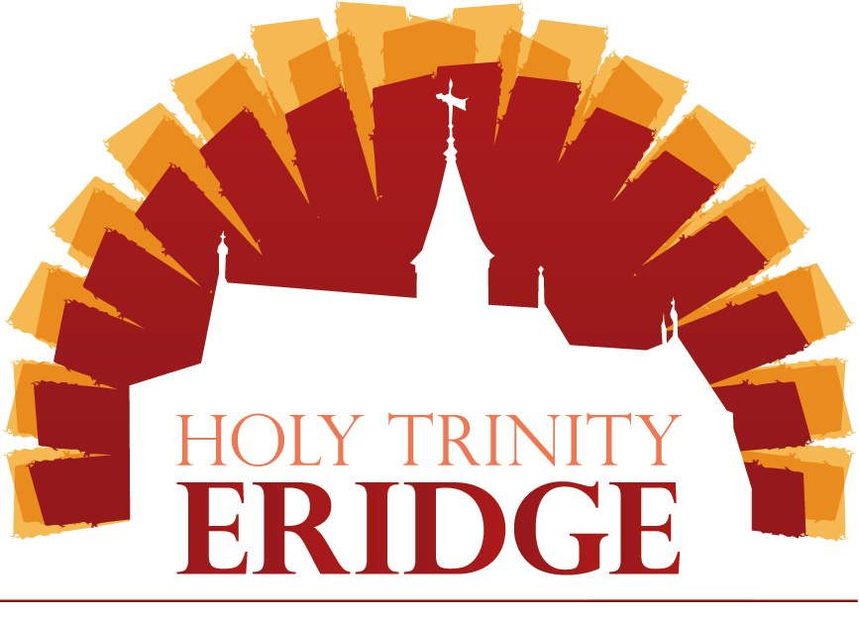

Baptism and Thanksgiving Services
for your child at Frant and Eridge churches

Welcome!

We are so pleased you enquired about celebrating the birth of your child and looking to God for blessing in their future.

At Frant and Eridge we offer two options for people to welcome their child into our lives and the church; Thanksgiving and Baptism.

Have a look at the differences in the service (the words you say are in bold):

Baptism  In baptism, God calls us out of darkness into his marvellous light.  To follow Christ means dying to sin and rising to new life with him.  Therefore I ask:  Do you reject the devil and all rebellion against God?  I reject them.  Do you renounce the deceit and corruption of evil?  I renounce them.  Do you repent of the sins that separate us from God and neighbour?  I repent of them.  Do you turn to Christ as Saviour?  I turn to Christ.  Do you submit to Christ as Lord?  I submit to Christ.  Do you come to Christ, the way, the truth and the life?  I come to Christ. | Thanksgiving  Do you receive these children as a gift from God?  We do.  Do you wish to give thanks to God and seek his blessing?  We do.  As Jesus took children in his arms and blessed them, so now we ask God’s blessing on N.  Heavenly Father, we praise you for his/her birth;  surround him/her with your blessing  that he/she may know your love,  be protected from evil,  and know your goodness all his/her days.

Why Thanksgiving?
It may be that the Baptism declarations are not where you are at the moment, or perhaps you would rather have a small thanksgiving with just family, this option might be for you!

Thanksgiving services are a wonderful time of celebrating the life of your child and giving thanks to God for them. It involves the minister holding your child and asking for God’s blessing over them, and the congregation praying for them.

If you would like any of your family or friends to be your child’s supporters/sponsors they can be involved in the service too.
Why baptism?
Baptisms happen within our main church services, for your decision is not just between you and God, but about joining our world-wide Christian church family! When you are baptised, you will be declaring your intention to grow as a member of Christ’s Church. Being part of a church is vital so we can help and aid each other in our Christian faith.
We are always delighted to carry out baptisms for regular members of our congregation and for people who live within our parish who come to join us. If you live outside the parish boundaries, you are welcome to join our church, and after you have settled in over a few months as part of our church here we would be happy to have your baptism in our church. If you can’t do that, you can also get in touch with your local parish church where the baptism can take place.
As part of the Baptism you as parents affirm your faith in Jesus, and that you are seeking to live according to what God says in the Bible. Baptism is available to the child of a single parent or a married couple. It also means that Mother and/or Father must be baptised themselves, or if you would like, you can be baptised at the same time in a family baptism! Your child’s Godparents must be baptised also.
How much do these services cost?
Nothing! There is no fee for Baptism or Thanksgiving but there will be an opportunity for you to make a donation. For those families who are part of the church family here you can give and support the work of the church through regular giving.
What about preparation?
Every parent needs some help in life, and we want to help prepare you, not only for the service but for your life as a parent, looking to God. This will mean meeting with the rector or one of our team where we can chat about the service and what the promises and declarations mean for you, as well as any questions about the Christian faith and how we can continue to encourage you in your life together. The church family would also love to get to know you, and so we ask that you come to church six times before the baptism.
What’s the next step?
Fill in the application form below and the rector or one of our team will get back to you about next steps.
I pray every blessing on you as you take this next step in your life.
-Rev Brendan Martin
Application for Thanksgiving for the Birth of a Child

Date of proposed Thanksgiving

Full Name of the child
Age
and date of birth

Father’s full name

Mother’s full name

Address

Contact | Home phone  Mobile  Email

Application for the Baptism of a child

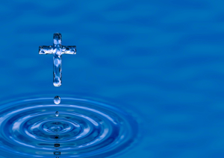
Date of proposed Baptism

Full Name of the person to be baptised
Age:
Date of birth:
Male/Female:

Father’s Title:
Father’s full name:

Father’s occupation
Has the father been baptised? |  | Has the father been confirmed?
Mother’s Title:
Mothers full name:

Mother’s occupation

Has the mother been baptised? Has the mother been confirmed?

Email:

Address

Telephone numbers | Home  Mobile

